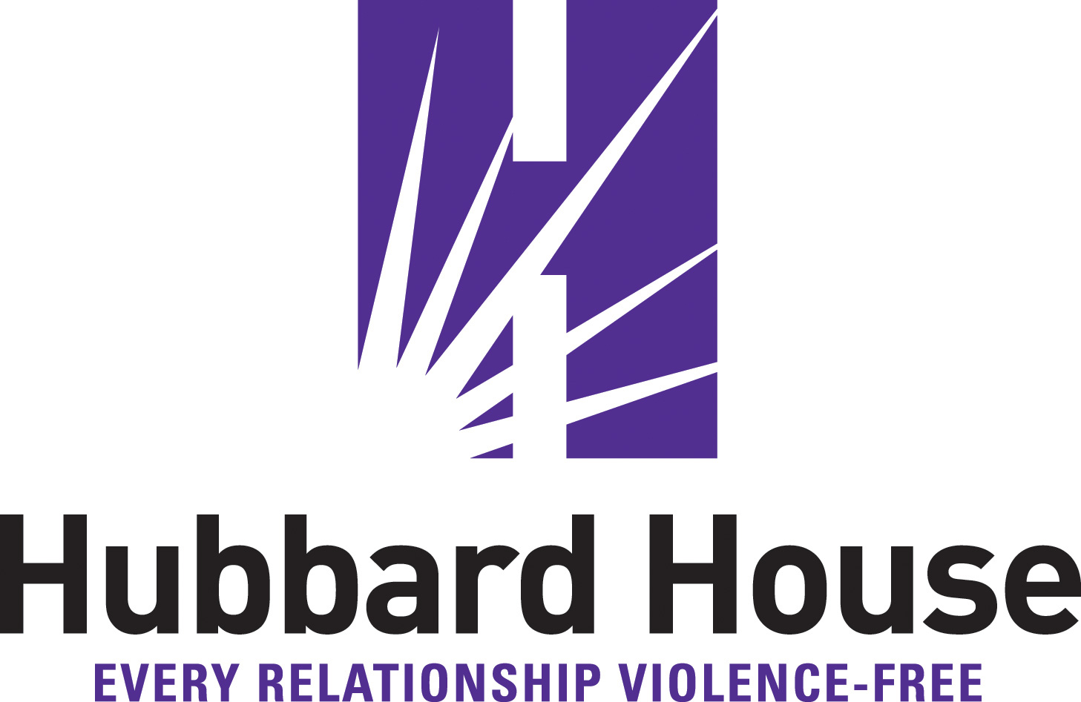

HUBBARD HOUSE’S 27TH ANNUAL BARBARA ANN CAMPBELL MEMORIAL BREAKFAST CREATES AWARENESS, RAISES RECORD FUNDS

JACKSONVILLE, Fla., Oct. 5, 2021 — Today, Hubbard House’s 27th Annual Barbara Ann Campbell Memorial Breakfast program reached nearly 400 guests and raised more than $140,000, a record for the event. The live event included motivational remarks from leaders, inspirational stories from survivors, and remembrances of those lost to domestic violence, reminding attendees why this cause matters so much to so many.

In her remarks, Hubbard House CEO Dr. Gail A. Patin encouraged attendees to share about domestic violence and the hope and help available through Hubbard House with others in their circles to see lives saved. “Many of the survivors who come to us learned about our shelter and services through a friend or family member,” said Patin. “By sharing, you may be saving a life. You may be saving a whole family.”

One of Patin’s recommendations to attendees was to share posts from Hubbard House’s Domestic Violence Awareness Month social media campaign, #SurvivorsSpeakTruth. Each post provides the 24/7 Domestic Violence Hotline and Textline numbers. She also suggested attendees email education@hubbardhouse.org to schedule a free educational presentation for any groups they belong to or participate in, such as work, social or faith-based groups.

On October 1, at the Domestic Violence Awareness Month kick-off press conference, Hubbard House and partners released the 2020 Domestic Violence Fatality Report. It revealed that 14 domestic violence related deaths occurred in Duval County last year, and eight involved intimate partners. None sought help from Hubbard House.

Confirming the effectiveness of Hubbard House’s life-saving and life-changing programs, two survivors spoke at the breakfast, one who sought help from Hubbard House just once. The other sought services multiple times, over years. Both survivors found freedom and a fresh start.

One of the survivors, Melissa, explained, “I have been delivered out of a place of sadness, fear, and no hope to a place of joy, strength, and hope.”

Hubbard House Board President Bill Driscoll also spoke, encouraging attendees to play a larger role in the agency’s mission of strength, empowerment and social change for survivors of domestic violence and their families. He also affirmed the significance of the organization, saying, “Hubbard House is a life-protecting, life-saving and life-changing organization that is vital to our region.”

The breakfast is held annually in October during Domestic Violence Awareness Month, in memory of former Jacksonville Mayor Jake Godbold’s sister-in-law, Barbara Ann Campbell. Barbara Ann lost her life because of domestic violence. Proceeds raised through this event go toward Hubbard House’s life-saving and life-changing shelter and services.

The Breakfast is presented by the Endowed $10,000 Event Grant Fund established in 2015 by Delores Barr Weaver. Presenting sponsors included the Alan and Pam Green Family Foundation, VyStar Credit Union and Women’s Care Florida Foundation.

Individuals who are in an abusive relationship or know someone who is, are urged to connect with an advocate at Hubbard House’s 24-hour Domestic Violence Hotline, (904) 354-3114, or Textline (904) 210-3568.

Hubbard House is a full-service certified domestic violence center providing prevention and intervention to domestic violence survivors and their families in Duval and Baker counties in Northeast Florida.

###

